Carlisle Parish Councils Association
“Broadband meets Localism” Conference
Saturday 15 January 2011
Carlisle Race Course
Booking Form

To process this form please EITHER save it, fill it in, re-save it and then email it as an attachment to rural@carlisle.gov.uk OR complete the form without saving and email direct to rural@carlisle.gov.uk using the email icon on your Word toolbar.
There is a choice of morning, afternoon or all day sessions please insert numbers of people wishing to attend below:
Morning _______ Afternoon _______ All Day ________

Lunch and refreshments are included please insert the numbers of people having lunch _____
If you have any special requirements including allergies please let us know below

To cover costs we regret that we will need to invoice for £10 those that book lunch and subsequently cancel after 7th January or find that they are unable to attend on the day.

 | Attendee 1 |  | Attendee 2
Name: |  | Name:
Organisation |  | Organisation
Email: |  | Email:
Postal Address |  | Postal  Address
Post code |  | Post Code
Telephone |  | Telephone

Please choose one workshop for morning sessions for each person
The afternoon workshops will be allocated on arrival

Time: | Session | Title | Attendee  1 | Attendee  2
11.45am | A | “Making the most of what you have” Experts will explain how to improve your existing broadband service. This will include a video link to an expert outside of the county.
11.45am | B | “Community owned solutions” and what can be achieved when you work together in your community. This will include  examples from other parts of Cumbria.
Carlisle Parish Councils Association

PLEASE NOTE

Photographs may be taken during the conference and each of the workshops and may be used as part of the work of the Carlisle Parish Council Association

By signing this form you are aware of the booking terms and conditions

Signed: ____________________

Date: ______________________

If you require this application form in a different format such as large print, Braille, audio or in a different language please call 01228 817200 or email customerservices@carlisle.gov.uk




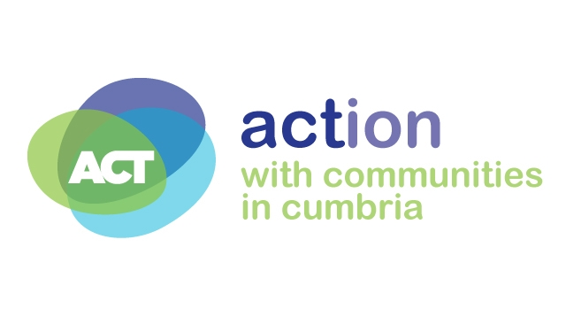

Completed forms need to be returned by Thursday 6 January 2011 to:
Lynne Hutchinson, Rural Support Officer,
Carlisle City Council, 7th Floor Civic Centre, Rickergate, Carlisle
or email: rural@carlisle.gov.uk

CPCA Secretary: Gwen Dumpleton Tel. 01697 743145, e-mail gwen.dumpleton@calc.org.uk

A District Association of Cumbria Association of Local Councils
www.calc.org.uk

