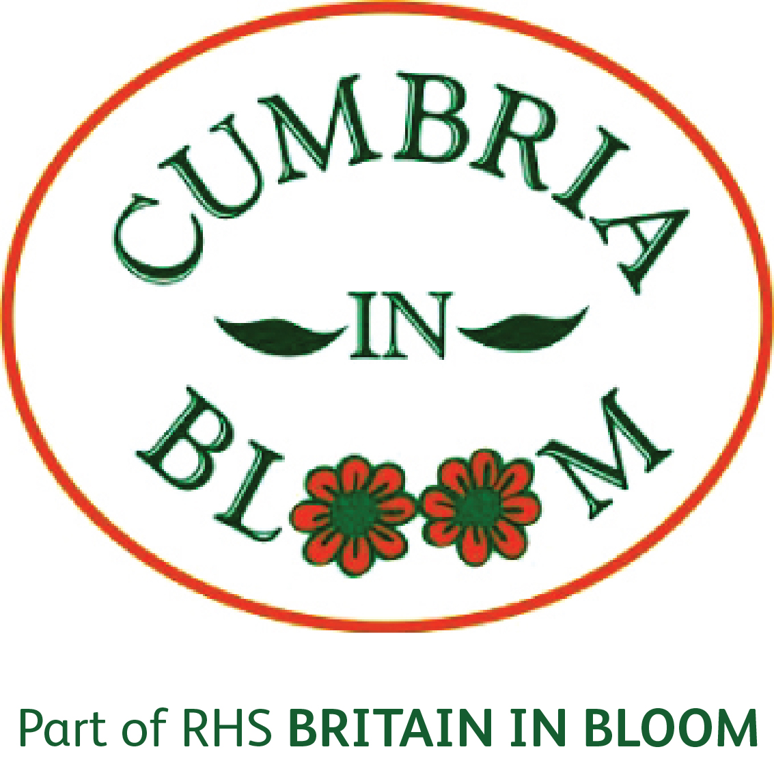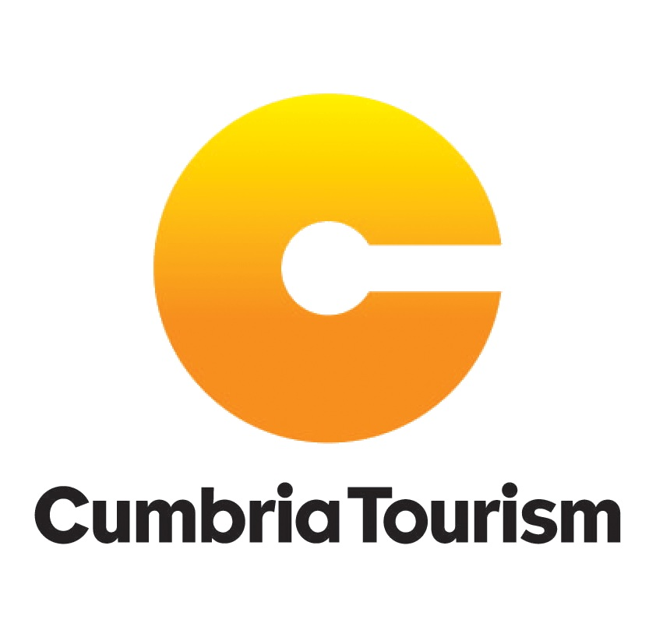

Registered Charity No: 1117828

Cumbria in Bloom, Tourism Business Entry Form 2015

Entries are now being taken for the 2015 Cumbria in Bloom Awards. There are three Tourism categories, please mark the box alongside the category you wish to enter and fill in your details.
Rose Bowl |  | Visitor Attractions, Tourist Information Centres, Caravan Parks and Self Catering

Jackie Sanderson Trophy |  | Hotels

CT Chairman’s Trophy |  | Bed and Breakfasts and Guest Houses
Please provide your entry’s full details here including address, telephone and email:
Business Name:
Address:
Telephone:
Email:
Please provide your name and contact details here, including address, telephone, and email, (if different from above):
Contact Name::
Address:
Telephone:
Email:

Once complete please return your form no later than 30th April 2015 to Elizabeth Auld at lizauld@btinternet.com or lizhauld@gmail.com Judging will take place by the Cumbria in Bloom committee during late June/July and the winners will be announced in September and will receive notification from the Cumbria in Bloom committee.
This competition is open to non-members of the tourist board.

